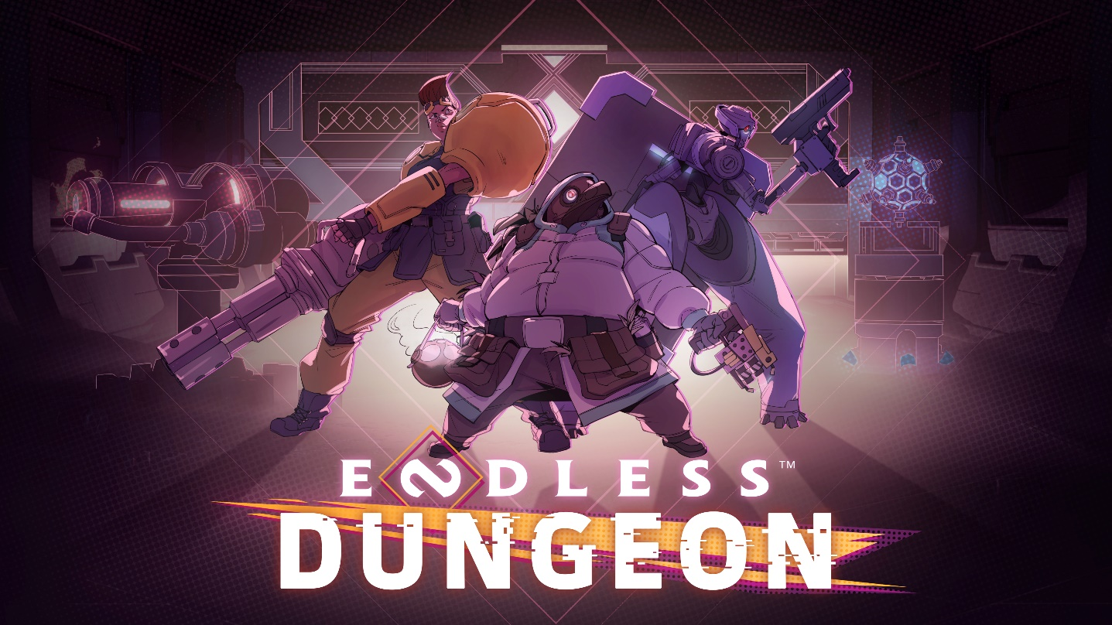

BUCKLE UP AND GET READY TO FACE THE ENDLESS DUNGEON

That’s right folks, the Endless Universe is back in action, and this time we mean business!

Endless Dungeon is a rogue-lite tactical die-and-retry twin-stick action bonanza.

[WATCH THE TRAILER]

Paris, December 10th – Here at Amplitude Studios, we believe that engaging in repeated suicide missions through abandoned space stations builds character. That’s why our newest title is Endless Dungeon, revealed tonight at The Game Awards. It’s a rogue-lite tactical action game, set in our award-winning (and often lethal) Endless Universe.
Shipwrecked on a mysterious space station, you’ll need to recruit a team of heroes and protect your crystal against never-ending waves of monsters. Or die trying, get reloaded, and try again!

ABOUT THE GAME
Fans of our previous game Dungeon of the Endless might want to know: Shipwrecked, again? Is this a sequel? Well, the answer is both yes and no. You’ll just have to wait to get your hands on it to find out. In the meantime, here’s what you can expect:
- A brand spankin’ new story in the Endless Universe: A space station that went to the dogs a long time ago. Some folks have been marooned here for decades—it’s up to you to figure out what’s happening, how (and if) you might get out…
- Opening new doors for the rogue-lite genre: Behind every door is something that’s nasty, new, and different. But if you’ve got the right turrets, the right iron for the right target, well you might just live… to open the next door.
- Recruit your suicide squad: Round up your posse from a roster of peculiar characters and see if you can get to the core of the station in one contiguous piece. Control the whole squad by your lonesome or test your survival skills with friends in multiplayer!
- Crystals are forever: You're gonna mostly be concerned about the health of a rock. Which you’ll be carting with you along the way. Get ready to defend the crystal at all costs!

SIGN-UP NOW AND GET A FREE SKIN AT RELEASE
Before sending you off to certain death, we’d like to give you a gift: Sign up to the Endless Dungeon mailing list here, and get a free skin at release*
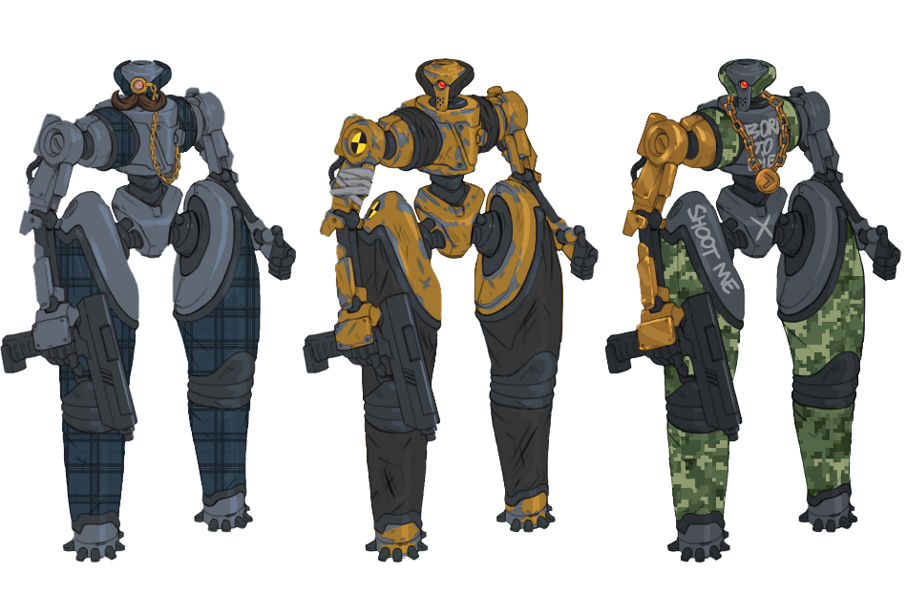
*Offer available for PC only (for now)
You can also vote on which free skin we create! Check out https://games2gether.com/

A GAME OF MANY PLATFORMS
We don’t discriminate; we believe everyone should get an equal chance to die in in the Endless Dungeon! Which is why we’re happy to announce that Endless Dungeon will be coming to both PC and consoles.
Good luck: we’ll meet you back at the saloon.
- The Amplitude team

